# **# ----WELCOME TO RUNNING INSTRUCTIONS----#**

1. git clone “<https://github.com/PersonalNischalPradhan/SwagLabsAutomationTest>” from terminal or you can use the inbuilt git functions from Intellij Idea tool OR use “Git Bash Here” at your designated folder.
2. Open Intellj Idea (recommended: IntelliJ IDEA Community Edition 2023.3.3, supports jdk 11) and **Open** the project from the designated folder. Select the folder which has pom.xml.
3. If Intellij Idea is used(recommended), then JDK can be downloaded directly from the tool itself. **File> Project Structure**, is the path to Download jdk 11.

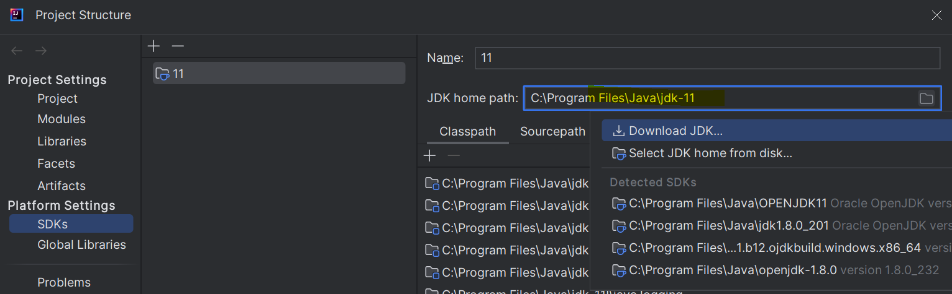

1. Add SDK in the Project Folder

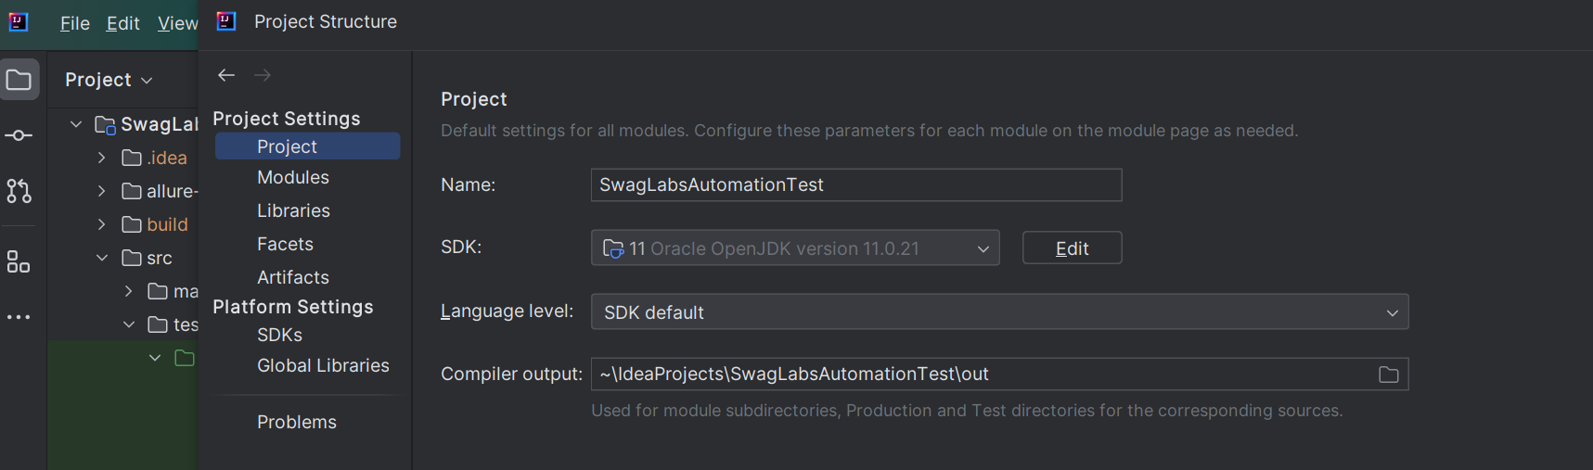

1. Settings>Plugins – Make sure that TestNG is there

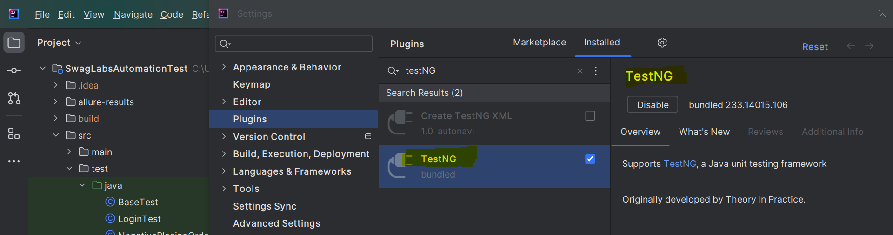

1. Maven is inbuilt (Intellij idea)

**OR , if you are using ECLIPSE, then install Maven,TestNG and JDK and mention the path in the system variables.**

1. Execute Maven clean compile from Intellij Idea or mvn clean compile from terminal.

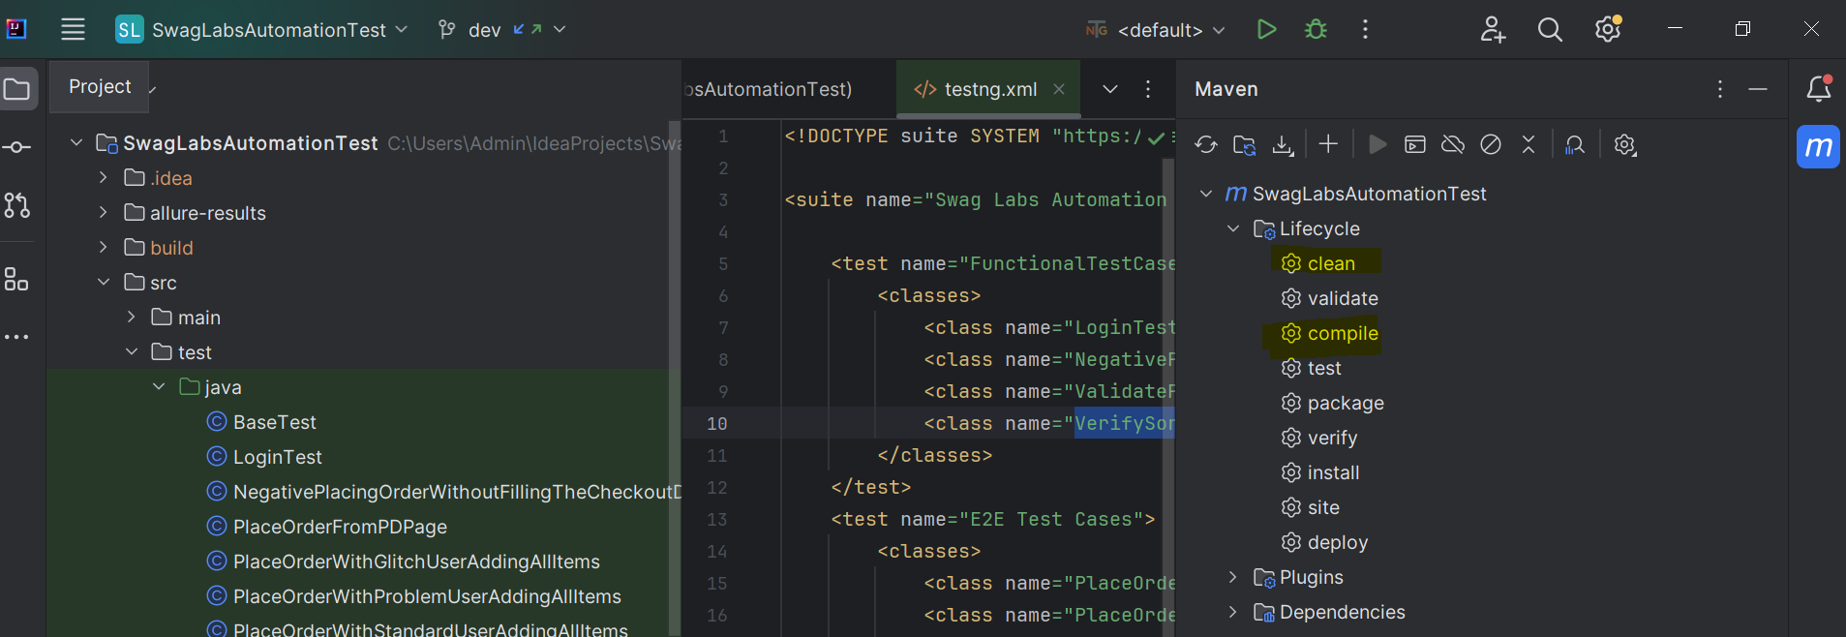

1. After downloading, build project as shown below or we are good to reload Project from Maven option

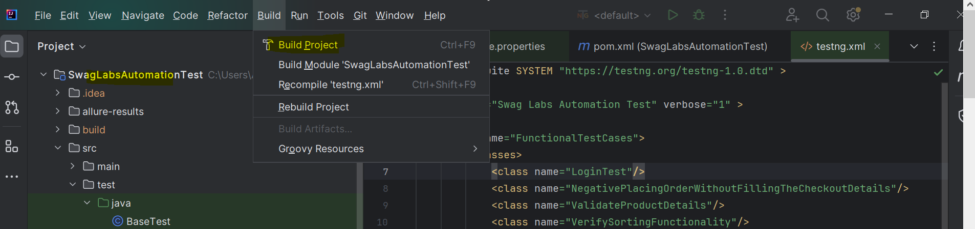

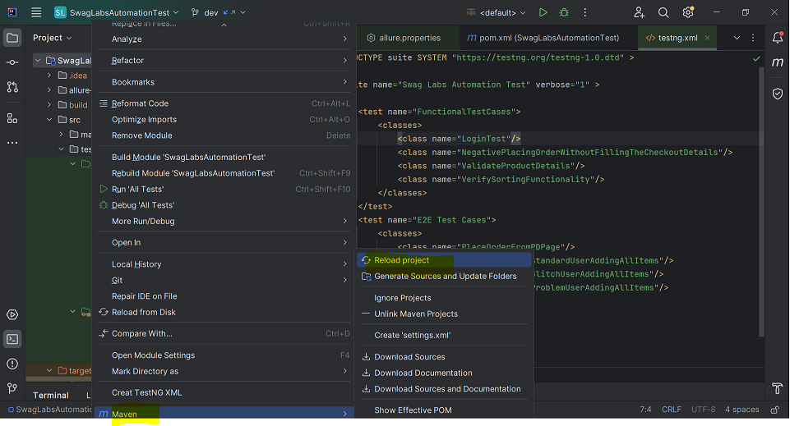

1. i>To run the test scripts on the terminal type: mvn clean test

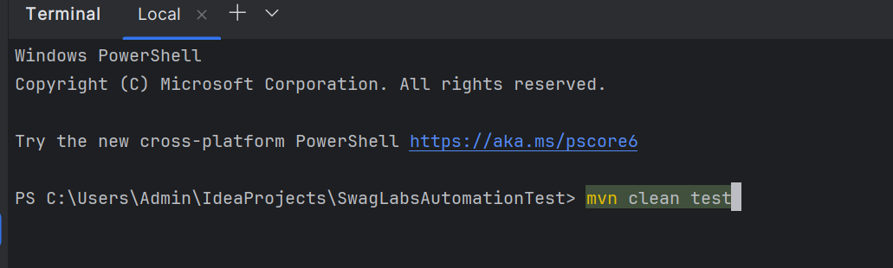

ii>Or go to the individual test 🡪 right click and then run or debug as per need

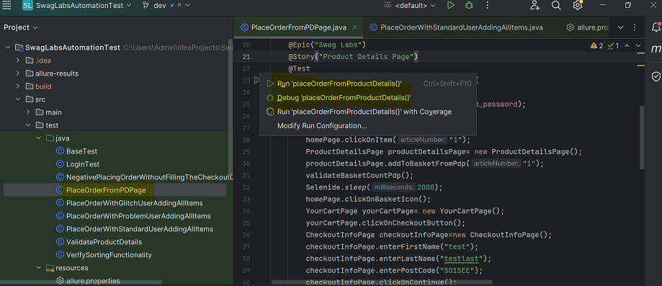

Running Allure Report : On the terminal type : allure serve target/allure-results

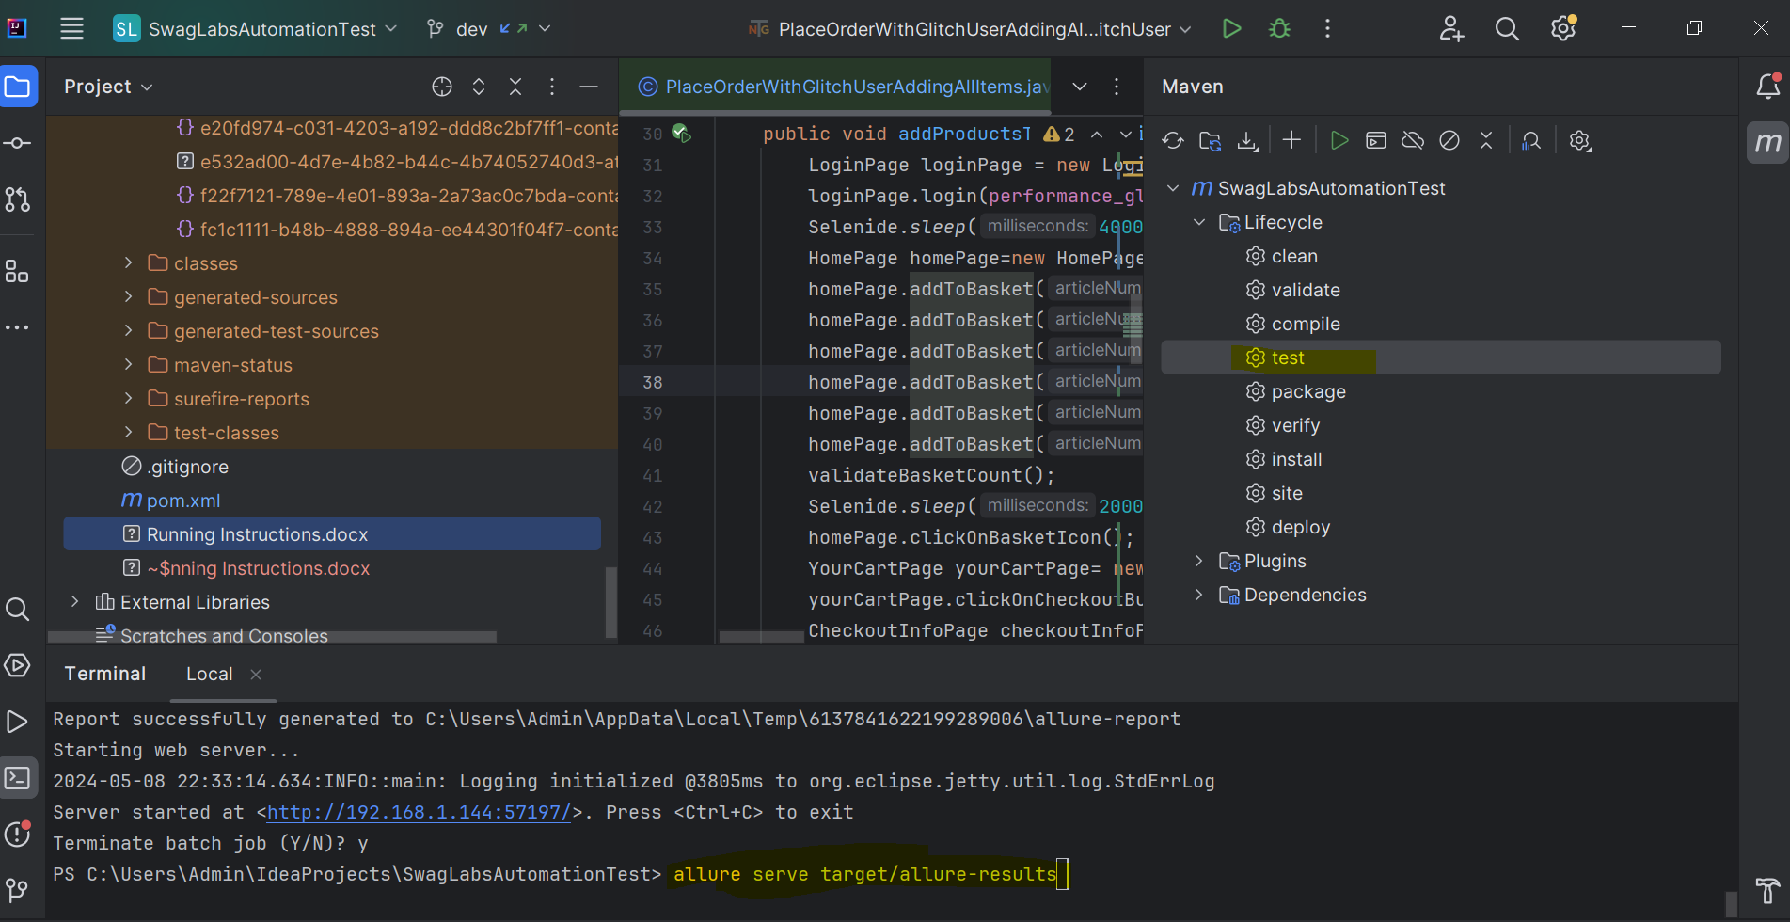

iii> as this automation project is integrated with Jenkins, we can run through it as well.

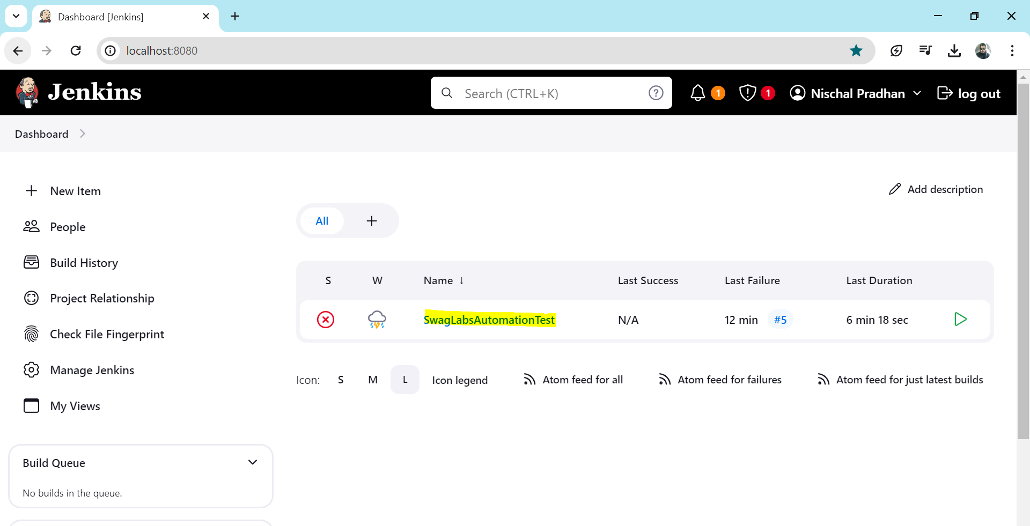

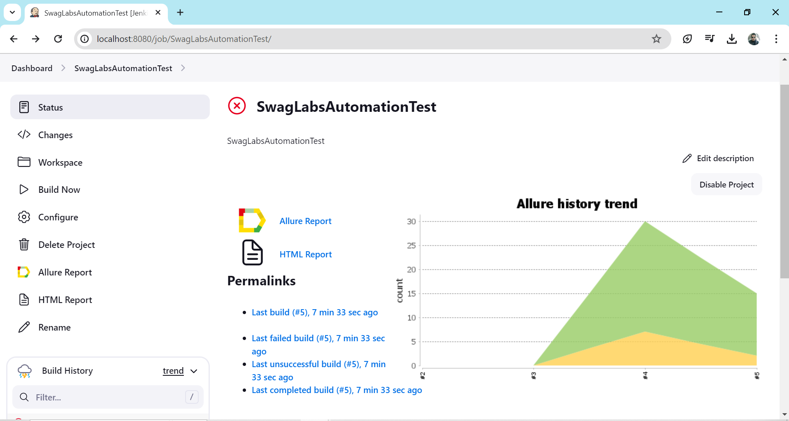

Allure report in Jenkins

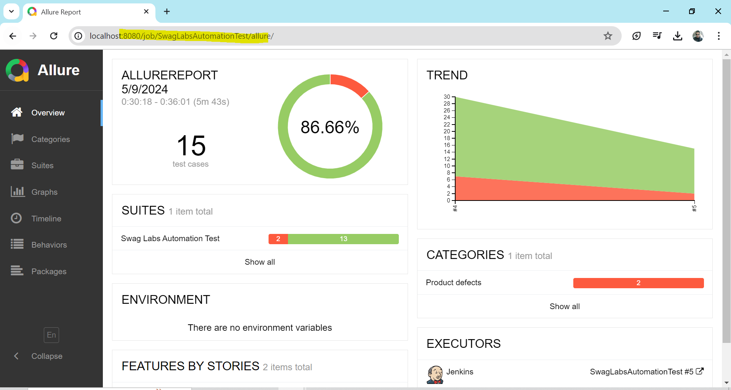

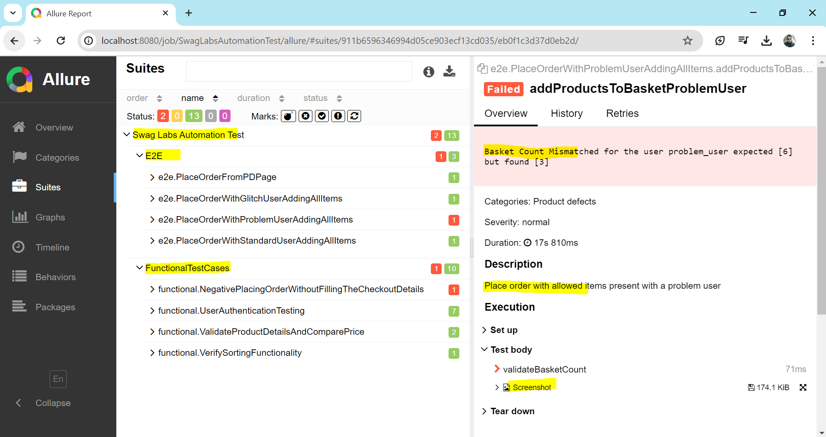

1. Allure Reports path is SwagLabsAutomationTest\target\allure-results

But to view the Allure Report as HTML view we need to run the command:

allure serve target/allure-results

This generates an HTML report:

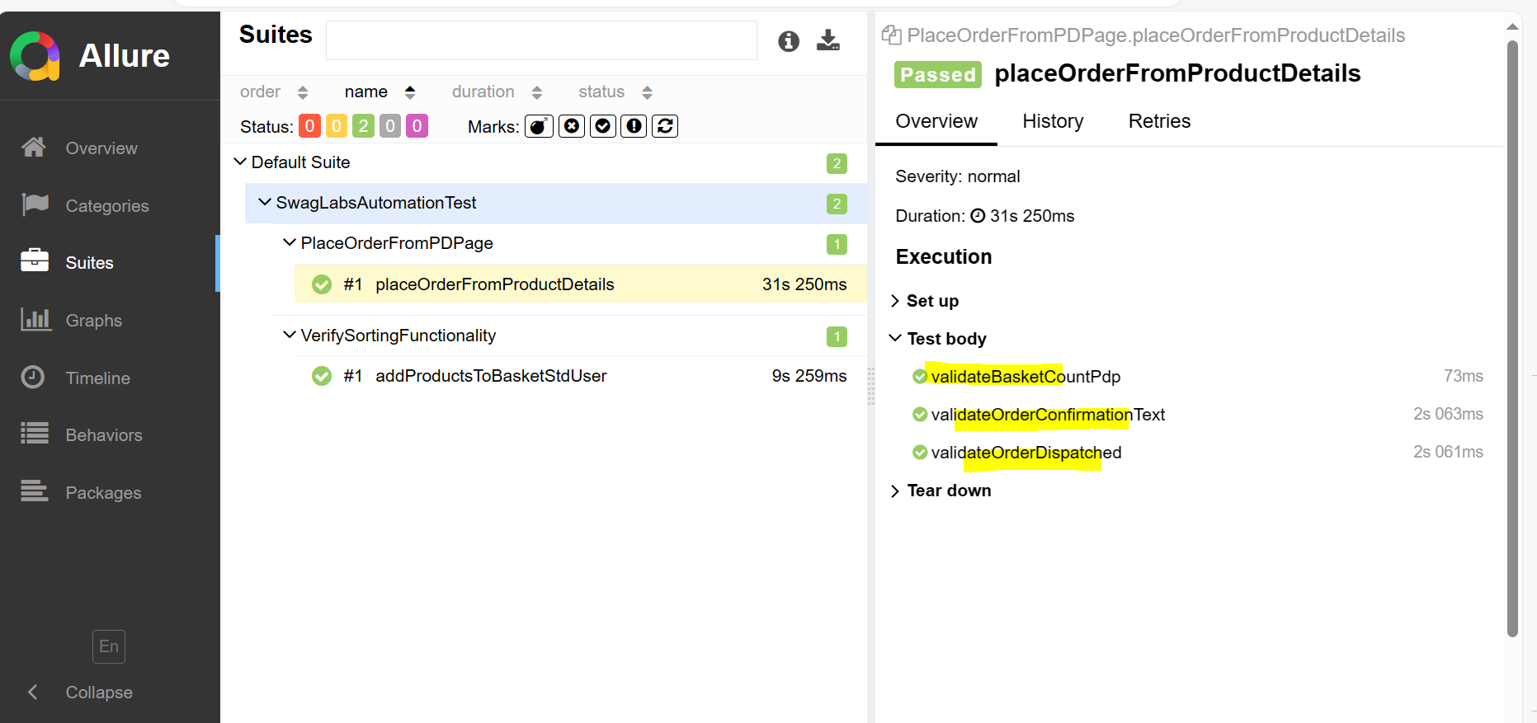

Allure report would be generated :

Allure Overview:

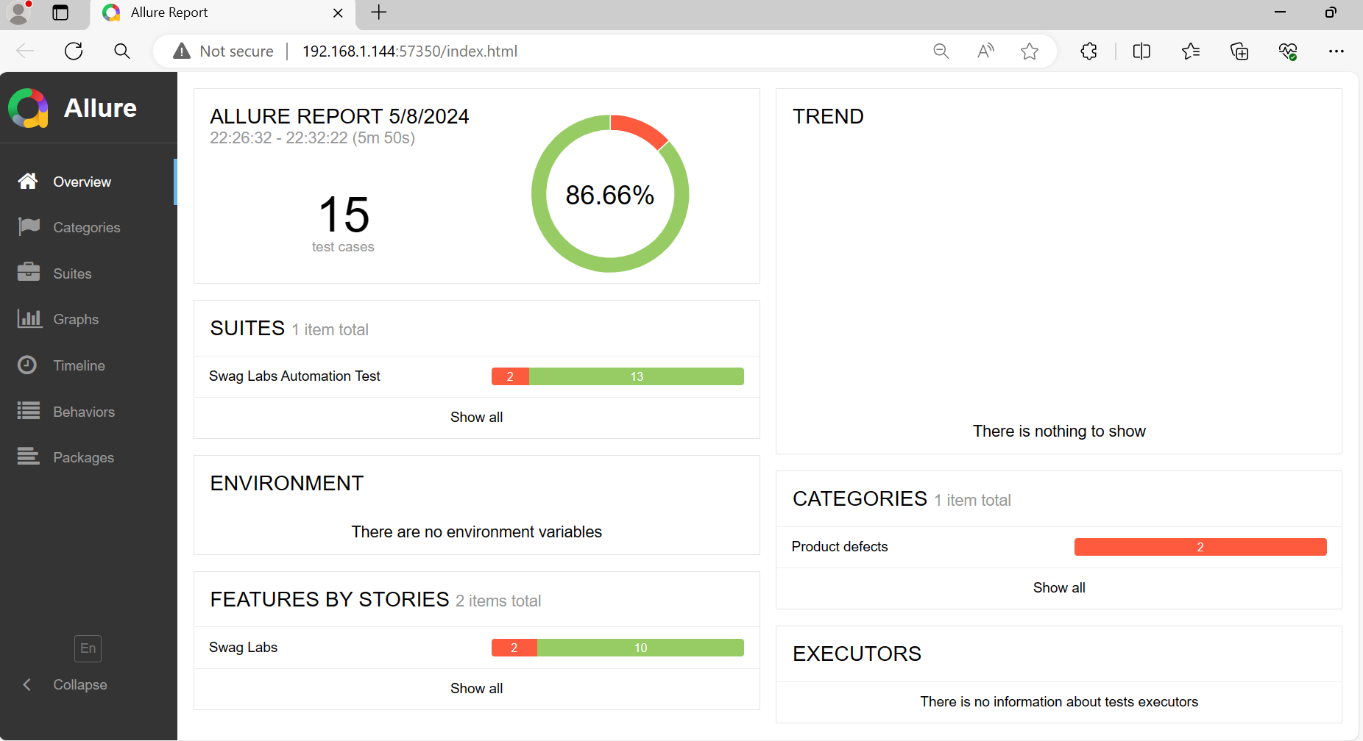

Categories : shows the issue

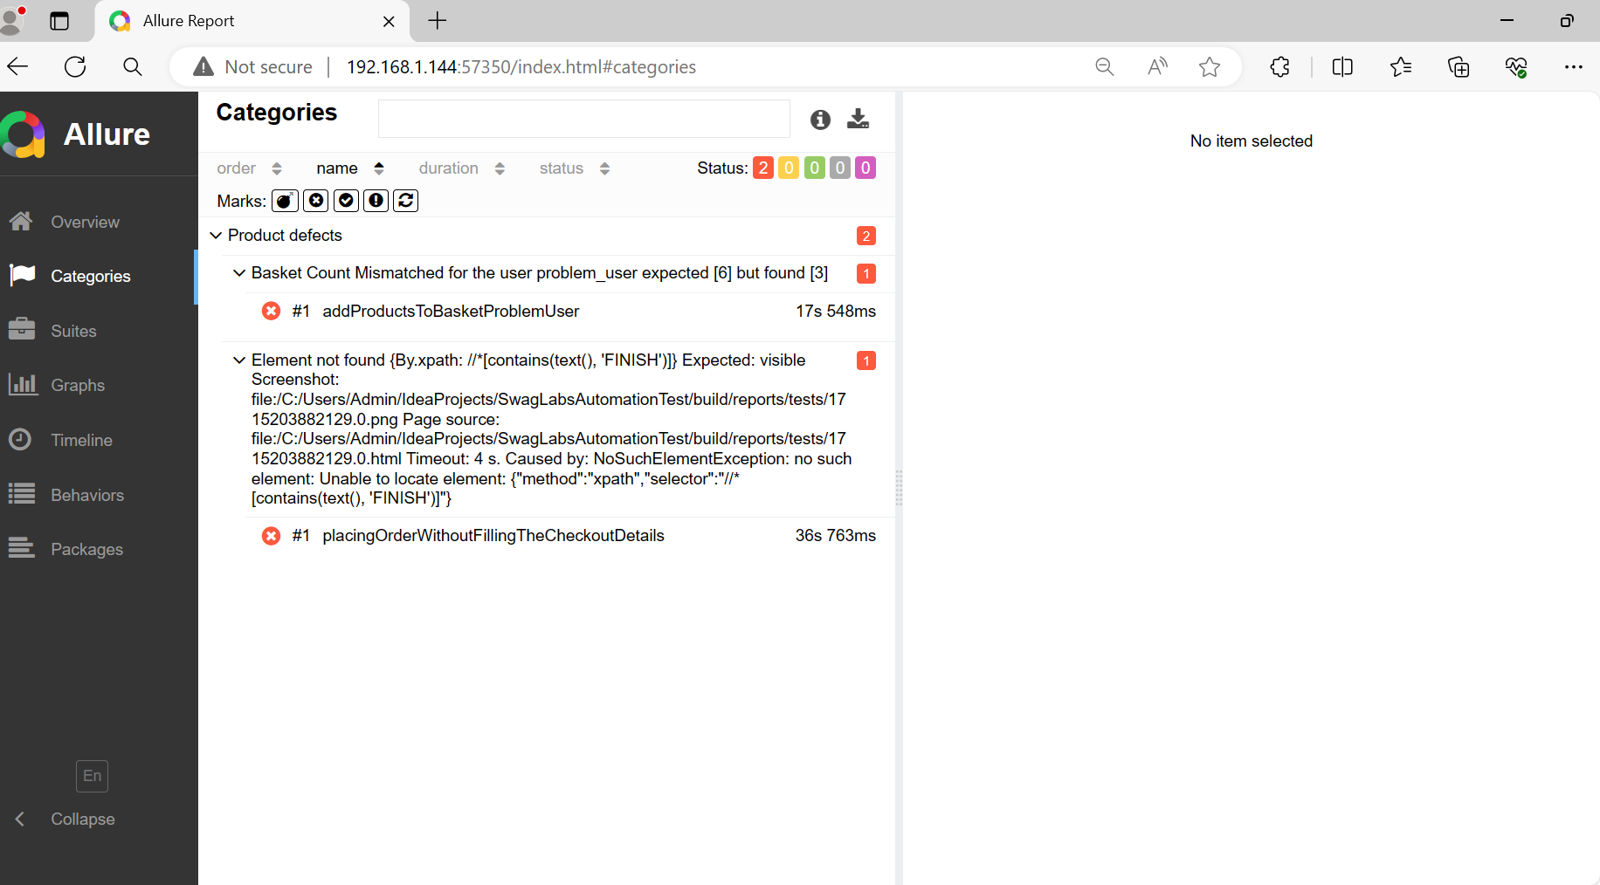

Suites: shows all the details

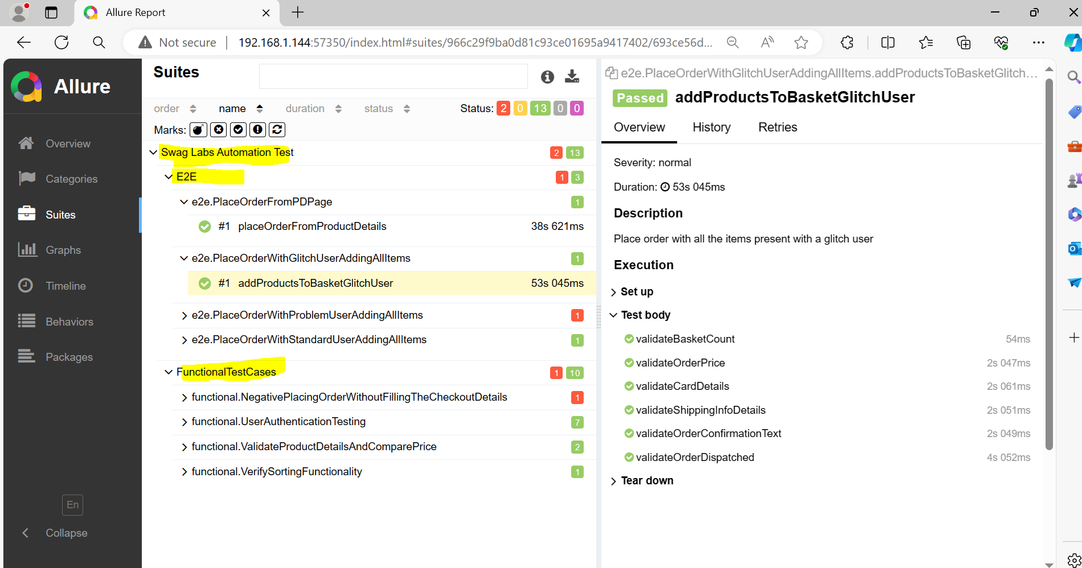

Failed script shows the screenshot and reason:

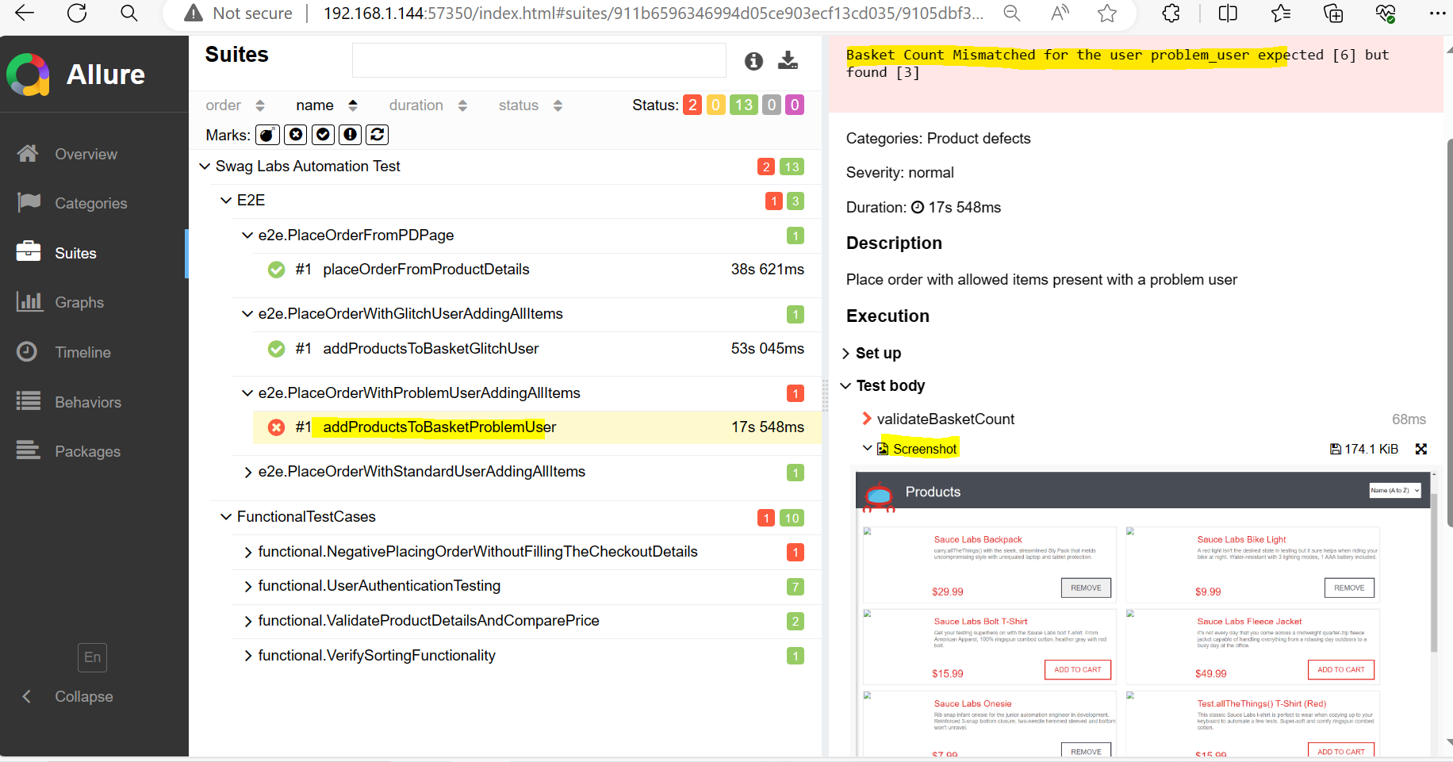

Graph show the percentages

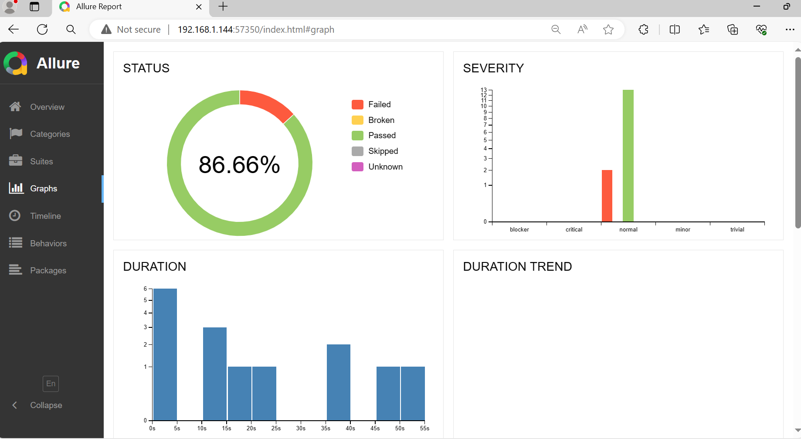

**Page Object Model:**

